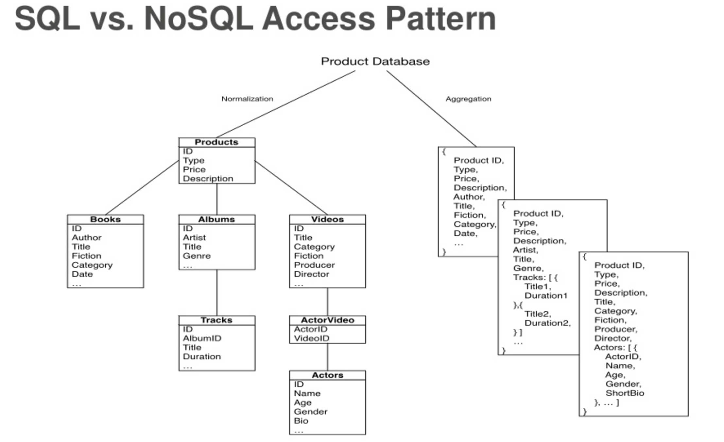

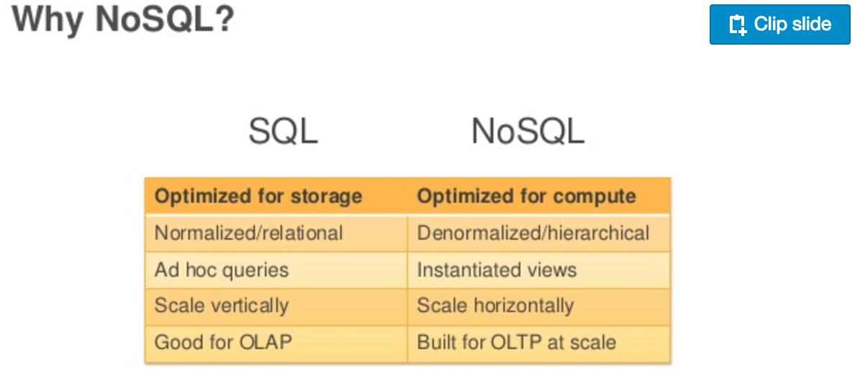

|  |  |
| --- | --- |
| **Use an RDBMS when you need/have...** | **Use NoSQL when you need/have...** |
| Centralized applications (e.g. ERP) | Decentralized applications (e.g. Web, mobile and IOT) |
| Moderate to high availability | Continuous availability; no downtime |
| Moderate velocity data | High velocity data (devices, sensors, etc.) |
| Data coming in from one/few locations | Data coming in from many locations |
| Primarily structured data | Structured, with semi/unstructured |
| Complex/nested transactions | Simple transactions |
| Primary concern is scaling reads | Concern is to scale both writes and reads |
| Philosophy of scaling up for more users/data | Philosophy of scaling out for more users/data |
| To maintain moderate data volumes with purge | To maintain high data volumes; retain forever |